Assignment 11
Exceptional Handling

- Write a simple program to demonstrate the use of try, catch and throw (in all three forms), in exceptional handling. You may use function to throw in all forms.
Code:
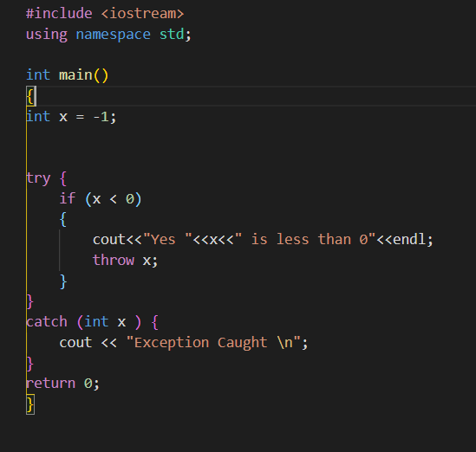
Output:
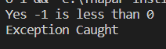

- Write a C++ Program to demonstrate the use of multiple catch with single try, include the default catch (if occurring exception doesn’t match the set of multiple catch blocks). Include the following exception scenarios catch in multiple scenarios, including the default case:
- divisible by 0
- vote right only if age is greater than 18
- only alphabets are allowed.
You may include these scenarios in single or multiple programs.
Code:
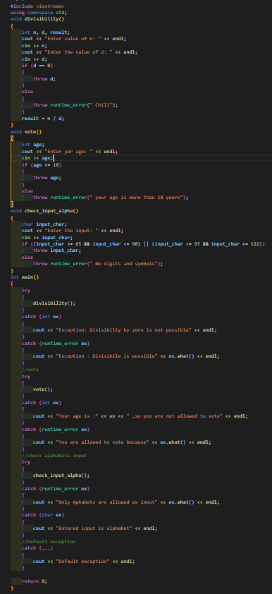
Output:
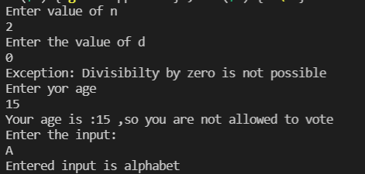
- Write a C++ program to illustrate the use of user-defined exception and the mechanism to re-throwing it.
Code:

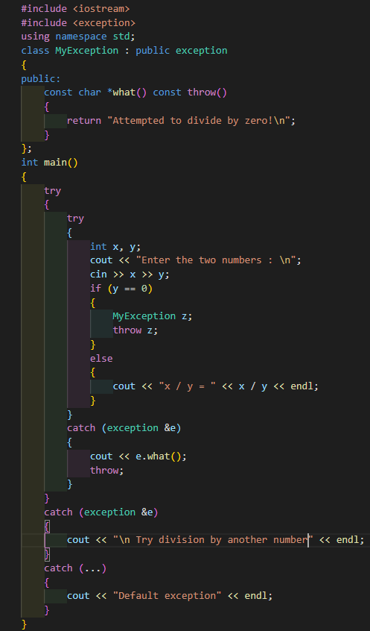
Output:
